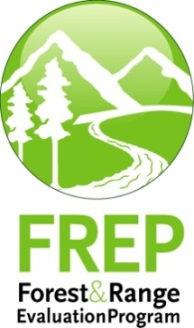
Multiple Resource Value Assessment (MRVA)
Kispiox Timber Supply Area
Skeena-Stikine Natural Resource District
December 2013

Foreword
Forest management in British Columbia is governed by a hierarchy of legislation, plans and resource management objectives. For example, federal and provincial acts and regulations, Land Use and Forest Stewardship plans, and protected areas and reserves collectively contribute to achieving balanced environmental, social and economic objectives. Sustainable forest management is key to achieving this balance and a central component of forest management certification programs. The purpose of the Multiple Resource Value Assessment (MRVA) report is to provide resource professionals and decision makers with information about the environmental component of this ‘balance’ so that they can assess the consistency of actual outcomes with their expectations.

The Forest and Range Practices Act (FRPA) lists 11 resource values essential to sustainable forest management in the province; biodiversity, cultural heritage, fish/riparian and watershed, forage and associated plant communities, recreation, resource features, soils, timber, visual quality, water, and wildlife. The MRVA report is a summary of the available field-based assessments of the conditions of these values. Field assessments are generally conducted on or near recently harvested cut blocks and therefore are only evaluating the impact of industrial activity and not the condition of the value overall (e.g. they don’t take into account protected areas and reserves). Most of the information is focused on the ecological state of the values and provides useful information to resource managers and professionals on the outcomes of their plans and practices. This information is also valuable for communicating resource management outcomes to stakeholders, First Nations and the public, and as a foundation for refining government’s expectations for sustainable resource management in specific areas of the province.

I encourage readers to review the full report and direct any questions or comments to the appropriate district office.

(ADMs electronic signature here)

Tom Ethier
Assistant Deputy Minister
Resource Stewardship Division
Ministry of Forests, Lands and Natural Resource Operations

Multiple Resource Value Assessments—In Brief
Multiple resource value assessments show the results of stand and landscape-level monitoring carried out under the Forest and Range Evaluation Program (FREP). This report summarizes results for riparian, biodiversity, and water quality (sediment) monitoring conducted in the Kispiox Timber Supply Area and includes a district manager commentary of key strengths and weaknesses. Through MRVA reports, decision makers communicate expectations for sustainable resource management of public resources and identify opportunities for continued improvement.
Figure 1: Kispiox Timber Supply Area site-level resource development impact ratings by resource value with trend (Riparian and stand-level biodiversity trend by harvest year/era. Water quality trends by evaluation year.)
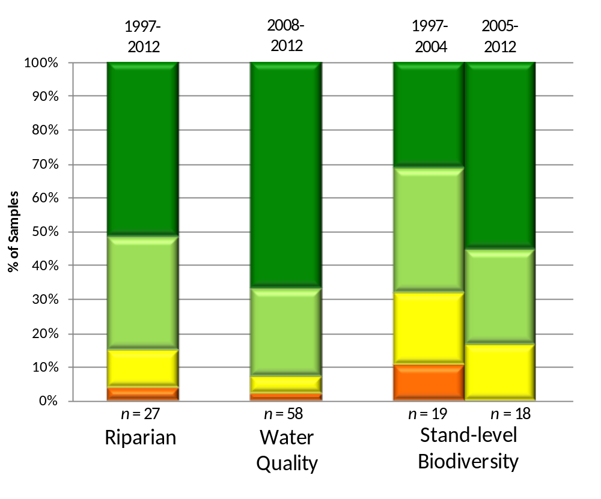

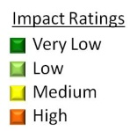

Important Context for Understanding this Assessment
The extraction and development of natural resources, along with natural factors (e.g., insects, wind, floods), influence and impact ecological condition. The goal of effectiveness evaluations is to assess these impacts on the state of public natural resource values (status, trends, and causal factors); such evaluations do not assess compliance with legal requirements. These evaluations help resource managers:
- assess whether the impacts of resource development result in sustainable resource management
- provide transparency and accountability for the management of public resources
- support the decision-making balance between environmental, social, and economic factors
- inform the ongoing improvement of resource management practices, policies, and legislation.
The resource development impact ratings contained in this report are based on assessments conducted within the areas where resource extraction takes place and do not reflect the ecological contributions of parks, protected areas, or other conservancy areas.
Although this report focuses on forestry-related activities, FREP monitoring protocols have also been applied to other resource sector activities, including mining (roads) and linear developments (hydro and pipelines). Procedures are being adapted to expand monitoring into these resource sectors over time.

Introduction
The development of the Forest and Range Practices Act (FRPA) had several key objectives, including:
- simplifying the forest management legal framework
- reducing operational costs to both industry and government
- allowing “freedom to manage”
- maintaining the high environmental standards of the Forest Practices Code of British Columbia Act (FPC).
As part of the results-based FRPA framework, the provincial government committed to conducting effectiveness evaluations and publically reporting the monitoring results. The science-based information provided by these evaluations will be used to determine whether FRPA is achieving the government’s objectives of maintaining high environmental standards and ensuring sustainable management of public resources. If those objectives are not being met the monitoring results will be used to help inform the necessary adjustments to practices, policies, and legislation. Government is delivering its effectiveness evaluation commitment through the Forest and Range Evaluation Program (FREP; for details, see http://www.for.gov.bc.ca/hfp/frep/). The 11 FRPA resource values monitored under FREP include: biodiversity, cultural heritage, fish/ riparian & watershed, forage and associated plant communities, recreation, resource features, soils, timber, visual quality, water and wildlife.
Multiple Resource Value Assessments (MRVAs) reflect the results of stand- and landscape-level monitoring carried out under FREP. The program’s stand-level monitoring is generally conducted on forestry cutblocks, resource roads, or other areas of industrial activity. As such, these evaluations provide a stewardship assessment of resource development practices. Landscape-level monitoring of biodiversity, visual quality, and wildlife resource values is more broadly an assessment of the overall landscape. Reports on MRVAs are designed to inform decision making related to on-the-ground management practices, statutory decision-maker approvals, and data for the assessment of cumulative effects.
This report summarizes FREP monitoring results for the Kispiox Timber Supply Area. MRVA reports clarify resource stewardship expectations, and promote the open and transparent discussion needed to achieve short- and long-term sustainable resource management in British Columbia.
MRVA reports are intended for those interested in the status and trends of resource values at the timber supply area (TSA) or natural resource district scale, such as natural resource managers and professionals, government decision makers, and First Nations. These reports are also useful in communicating resource management outcomes to the public.
Government managers and decision makers are encouraged to consider this information when:
- discussing district or TSA-level resource stewardship with staff, licensed stakeholders, tenure holders and First Nations
- clarifying expectations for sustainable resource management of public land
- integrating social and economic considerations into balanced decision making
- reviewing and approving forest stewardship plans
- developing silviculture strategies for TSAs
- assessing Timber Supply Reviews and their supporting rationale
- informing decision making at multiple scales.
Natural resource professionals are encouraged to consider this information, along with other FREP information such as reports, extension notes, protocols, and monitoring data to:
- maintain current knowledge of the resources they manage
- inform professional recommendations and decisions, particularly when balancing environmental, social, and economic values
- enhance resource management, consultation, and treaty rights discussions between First Nations, government, and licensees.
Published FREP reports and extension notes contain detailed findings for each resource value. These documents are available on the FREP website at: http://www.for.gov.bc.ca/hfp/frep/publications/reports.htm. Licensees can request data collected on their operating areas. FREP staff will assist licensees with the analysis of their data and the preparation of licensee-specific MRVA reports.
Although this MRVA report documents monitoring results at the district or TSA level, the MRVA concept is scalable. Reports for individual licensees, treaty settlement areas, or landscape units can be produced when sufficient monitoring data is available. Reports can also be prepared at the regional or provincial levels. This report provides site-level resource value assessments and trends through comparisons of cutblocks harvested before 2005 with those harvested in 2005 or later (where data is sufficient). FREP’s site assessment monitoring results on each resource value are categorized by impact (very low, low, medium, or high). This classification reflects how well site-level practices achieve government’s overall goal of sustainable resource management. Site-level practices that result in “very low” or “low” impact are consistent with sustainable management objectives. Practices resulting in “high” impact are seen as inconsistent with government’s sustainability objectives. For a description of the MRVA methodology see Appendix 1.

Kispiox Timber Supply Area – Environmental and Stewardship Context
The 1.22 million hectare Kispiox TSA is administered by the Ministry of Forests, Lands and Natural Resource Operations’ Skeena Stikine Natural Resources District office in Smithers. The population of approximately 6 000 people resides in communities including the Hazeltons, Two Mile, Gitanyow, Glen Vowell (Sik-e-dakh), Kispiox, Kitwanga, Cedarvale, and Kitseguecla, located along Highway 16 and 37 corridors.
First Nations with traditional territories that overlap into Kispiox TSA include the Gitxsan, Wet'suwet'en, Gitanyow, Nisga'a, Nat'oo'ten and Tsimshian. The Gitxsan Nation has five villages within the TSA (Gitanmaax, Sik-e-dakh, Kispiox, Gitsegukla and Gitwangak). Wet'suwet'en and Gitanyow each have one (Hagwilget and Gitanyow). The Nisga'a Treaty finalized in April 2000 provides for a Nass Wildlife Area that overlaps part of the TSA. Cultural heritage features are abundant and include traditional use sites, major trading trails, and archaeological features.
Kispiox TSA transitions coastal and interior climates and is ecologically diverse. Engelmann Spruce-Subalpine Fir (ESSFwv), Interior Cedar-Hemlock (ICHmc1, mc2), Coastal Western Hemlock (CWHws2), and Sub-Boreal Spruce (SBSmc2) biogeoclimatic zones dominate. Forests are dominated by hemlock and subalpine fir. Spruce (Engelmann, white and hybrid), lodgepole pine, western redcedar, amabilis fir and cottonwood are present at lesser levels.
Topography is mountainous, with a mix of wide and narrow forested drainages between ranges. Stream density is very high. Major rivers include the Skeena, Bulkley, Babine, and Kispiox. The confluence of the Skeena and Bulkley rivers occurs near the Hazeltons.
The Kispiox allowable annual cut (AAC) is 977 000 m³/year based on a 328 000 hectare timber harvesting land base (THLB). Of this total, 177 000 m³ was geographically partitioned in 2008 to remote areas, to deter further overharvest of accessible areas. Timber supply is considered stable for the next 5 decades, after which there is a predicted decline to a 729 000 m³/yr long-term harvest level.
Prior to 2001 the public sector (education, health, safety, and government administration) was the dominant employer (45 percent of all jobs), with the forestry sector second at 30 percent. Rate of harvest was at or near AAC levels.
Employment in the forestry sector declined sharply in 2001 when Skeena Cellulose Inc. (SCI) went into receivership and its Carnaby sawmill closed. In 2004, the Kispiox Forest Products sawmill in South Hazelton also closed. In 2006 direct forestry sector employment in the TSA accounted for less than 10 percent of all jobs. Since 2002 rate of harvest has averaged 21 percent of AAC with recent declines to less than 15 percent, and has never exceeded 35 percent. Most volumes are now processed at the PIR mill in Smithers, with a small proportion going to remaining local small mills (e.g. Kitwanga Forest Products sawmill) or export.
TSA forests are comprised of scattered valuable stand types that yield a high proportion of sawlog-grade timber, in a solid matrix of very marginally economic types. Historic harvest and road building has followed the pattern of valuable stand types through drainages, with the exception of the mid 1990’s and again in 2006 when pulp commodity prices were high. There is now extensive harvest, and extensive and deteriorated road infrastructure, in drainages in the two-thirds of the TSA south of Babine River.
Since 2006 the forest industry has targeted residual high-value patches along highways and mainlines for harvest. Waste levels tend to be high. There has been minimal new road building.
Kispiox TSA was generally unaffected by the recent mountain pine beetle epidemic, as mature pine leading stands comprise less than 8 percent of the THLB. The most significant forest health issue is a severe outbreak of Dothistroma needle blight, which causes recurrent needle defoliation and has frequently led to full mortality of young ICH and CWH pine plantations.
Non-timber resources and values are rich and diverse. They include stand and landscape-level biodiversity, community and fish sensitive watersheds, hydrologically stable watersheds, cultural heritage resources, fish and wildlife habitats, botanical forest products (e.g. pine mushrooms, berries), old and unique forests, scenic resources, and wilderness.
Wildlife and fish species of regional significance or at risk are present and include grizzly, moose, mule deer, mountain goat, raptors, bull trout and sockeye salmon. Black bears are widespread, and a population of Kermode extends into the western half of the TSA. Many species are dependent on the mature and old forest ecosystems within the TSA. Skeena River and tributaries provide important spawning habitat and migration routes for returning salmon.
The province has established legal objectives addressing these and other values through 1996, 2004, and 2006 strategic planning processes including species at risk notices, and Government Actions Regulation Orders. The province has also engaged Gitanyow, Gitxsan and Nisga’a in land use planning processes, to identify and inventory commonly held forest values and to co-develop legal objectives and forest management strategies intended be addressed in Forest Stewardship Plans (examples include the newly completed Cranberry and Nass South Sustainable Resource Management Plans)
The Cultural Heritage and Archeological Resource Inventory (CHARI), a continually updated inventory that identifies areas and trails of known and potential cultural and archaeological significance in Gitxsan, Gitanyow and Wet’suwet’en territories is an example of just such a successful inventory collaboration.
Within Kispiox TSA, FREP serves as one of a number of monitoring initiatives for objectives set by government. Other forms of monitoring are undertaken by government agencies, First Nations, licensees, and by volunteer organizations including the Smithers-based Babine Watershed Monitoring Trust (BWMT).
BWMT facilitates and funds monitoring initiatives with a focus on effectiveness monitoring of land use plans approved for the Babine watershed of Bulkley and Kispiox TSA’s. They have developed an internationally recognized science-based monitoring needs framework, built on consideration of risk/uncertainty thresholds for key values and indicators.
Locally, Skeena Region has initiated development of a Skeena Integrated Monitoring Framework intended to incorporate best elements of multiple monitoring initiatives, including FREP, the Skeena Cumulative Effects demonstration pilot, and, potentially, the initiative listed above.

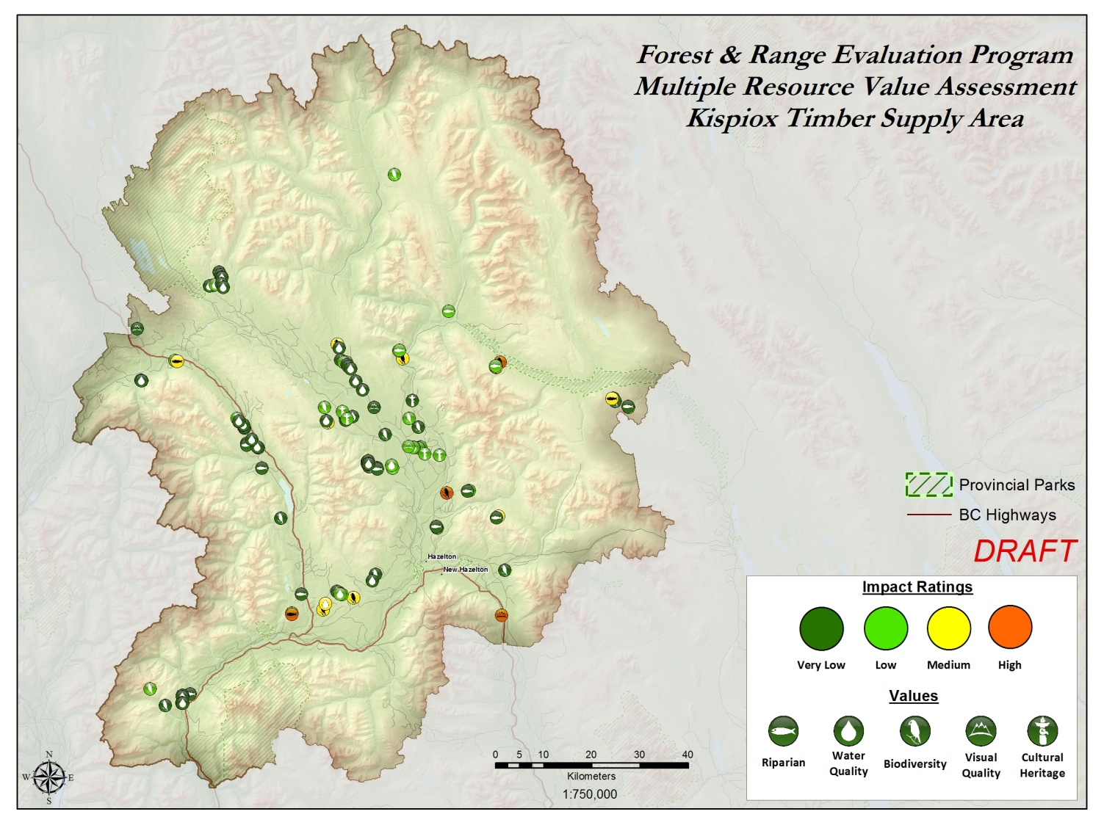
Figure 2: Kispiox Timber Supply Area, showing FREP sample locations and results (see http://www.for.gov.bc.ca/hfp/frep/publications/mrva.htm for a high-resolution version of this map).

Key Results by Resource Value and Opportunities for continued improvement
Table 1 shows the resource values assessed for the Kispiox Timber Supply Area, and includes a summary of key findings, causal factors, trends, and opportunities for continued improvement. Data are presented for FPC-era samples at sites harvested before 2005 and FRPA-era samples at sites harvested in 2005 or later. This approximates the Forest and Range Practices Act (FRPA) era, and allows for a comparison between earlier and later stewardship practices. The impact rating indicates the effect of resource development on the resource value, from “very low” to “high” impact.
Table 1: Resource development impact rating, key findings, and opportunities for improvement by resource value for the Kispiox Timber Supply Area.
Riparian: Resource Development Impacts on Stream Function
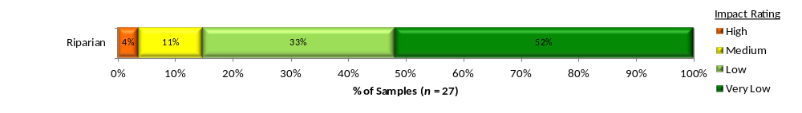
Summary:  Of the 27 streams monitored, 85% were rated “very low” or “low” harvest-related impacts: 52% of streams are Properly Functioning (“very low” impact), 33% are Properly Functioning with limited impact (“low” impact), 11% are Properly Functioning with impact (“medium” impact) and 4% are Not Properly Functioning (“high” impact).  Causal Factors:  Factors that contributed to “high” or “medium” impact ratings included: introduction of fine sediments, in-stream barriers to normal movement of sediment, in-stream logging slash, low moss levels indicative of unstable systems.  Number of Samples by Stream Class and Impact Rating: | Overall Stewardship Trend: Insufficient data  There were only 9 stream reaches sampled in the FRPA-era. Trending data will be given when more samples are collected.  Opportunities For Continued Improvement:  Two of the four “high” and “medium” impacted streams, had falling and yarding, and, low retention as the main cause of the condition of the stream. A third stream had sediment from a poorly deactivated crossing as contributor. The fourth stream had full retention in the riparian management zone but was impacted by windthrow initiated by a high wind event.
  Class | High | Medium | Low | Very low | Total
  S3 |  |  |  | 5 | 5
  S4 |  |  |  | 1 | 1
  S6 | 1 | 3 | 9 | 8 | 21
  Total | 1 | 3 | 9 | 14 | 27

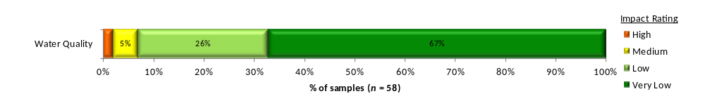
Water Quality (fine sediment): Resource Development Impacts on Water Quality
Summary:  Of the 58 road segments assessed, 93% were rated as “very low” or “low” road-related impact.  Site assessments show the range for potential sediment generation as 67% “very low” (“very low” impact), 26% “low” (“low” impact), 5% “moderate” (“medium” impact), 2% “high” or “very high” (“high” impact).  Causal Factors:  See opportunities for improvement for “high” or “medium” impacted road segments. Some opportunities will apply to ongoing maintenance issues, while others mainly apply to new road construction. | Overall Stewardship Trend: Insufficient data  Trending for water quality is based on survey years, to capture impact of road traffic and maintenance. This trending will occur when sufficient data is available.  Opportunities For Improvement:  For the four road segments that were in “high” or “medium” impacted categories, the main suggested solution was to armour, seed or protect bare soil, and to use good quality materials and crown roads.
Stand-level Biodiversity: Resource Development Impacts on Stand-Level Biodiversity
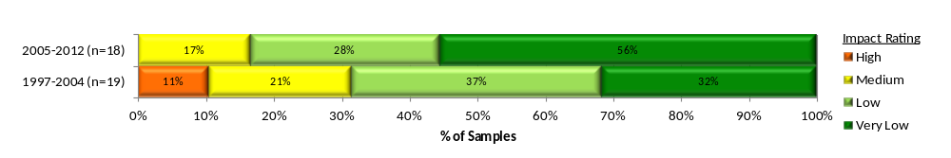
Summary:  Of 37 cutblocks, 76% of sites were rated as “very low” or “low” harvest-related impact.  Considering total retention, retention quality, and coarse woody debris quantity and quality, 43% sites are rated as “very low” impact on biodiversity, 32% as “low,” 19% as “medium,” and 5% as “high.”  Causal Factors:  87% of all blocks had more than 3.5% treed retention. Average retention was 19.9% in the FPC-era and 21.5% in the FRPA-era. Average cutblock size increased from 32 to 53 hectares. Large snag retention is low for the ICHmc biogeographic ecosystem classification (BEC) zone compared to that expected from baseline. Large tree density overall (≥70 cm, 50 or 40 dbh dependent on BEC) is low compared to baseline. Coarse woody debris quantity in the harvested areas has increased from an average of 195 m³/ha in the FPC-era to 272 m³/ha in the FRPA-era. Coarse woody debris quality in terms of big pieces (≥20 cm and ≥10 m) has increased. |  | Overall Stewardship Trend: Improving ↑  There is improvement in resource development impact trends due small increase in amounts of retention and, higher coarse woody debris quantity and quality in the FRPA-era.  Opportunities For Continued Improvement:  Leave treed retention on every cutblock and continue to leave higher numbers of larger patches (>2 ha) which can provide closer to interior habitat conditions. Continue trend to good quality coarse woody debris (i.e., big pieces). Continue trend to retaining multiple tree species on blocks. Increase retention quality by retaining large snags and big diameter trees in densities similar to pre-harvest conditions.

Visual Quality: Resource Development Impacts on Achievement of Visual Quality Objectives (VQO)

There are currently only four Visual Quality samples in the Kispiox Timber Supply Area. Analysis will be completed in subsequent years when more samples are available.
Cultural Heritage: Resource Development Impacts on Cultural Heritage Resources
There are currently only six Cultural Heritage samples in the Kispiox Timber Supply Area. Analysis will be completed in subsequent years when more samples are available.
Landscape-level Biodiversity: Is the forested matrix at the landscape-level providing the range of habitat understood as necessary for maintaining ecosystem function and old and mature forest dependant species?
This protocol is in development. The three primary landscape-level biodiversity indicators are: (1) site index by leading species (ecosystem representativeness); (2) percent of TSA by age class (young, mid-, mature, and old forest); and (3) percent interior habitat of old forest. Each indicator is categorized by percent in non-commercial land base, timber harvesting land base, and protected areas. Data for these indicators is derived from Hectares BC and other spatial databases.

Resource Value Stewardship Results Comparison
Table 2 provides ratings of stewardship effectiveness at varying scales. Effectiveness is determined by the percentage of samples with a “very low” or “low” resource development impact rating. Appendix 2 shows stewardship effectiveness results by resource value for the North, South and Coast Areas and the province as a whole.
Table 2: Stewardship effectiveness within the Skeena Region as determined by resource development impact rating (ID = Insufficient Data; sample sizes in brackets).
Resource Value | Effectiveness of Practices in Achieving Resource Stewardship Objectives:  % Very low + Low Resource Development Impact Rating (sample size in brackets)
Resource Value | Skeena Region Comparison |  |  |  |  |  |  | Skeena Regionª
Resource Value | Kispiox TSA | Lakes TSA | Morice TSA | Kalum TSA | Nass TSA | Bulkley TSA | North Coast TSA | Skeena Regionª
Riparian – all data  FRPA-era data  FPC-era data | 85% (27)  ID (9)  83% (18) | 64% (36)  68% (19)  59% (17) | 74% (42)  83% (18)  67% (24) | 75% (53)  73% (15)  81% (36) | ID (9) | 90% (31)  93% (14)  88% (17) | 76% (45)  76% (21)  75% (24) | 77% (243)  80% (100)  75% (141)
Water quality – all data  2010–2012 samples  2008–2009 samples | 93% (58)  ID (32)  ID (26) | 52% (83)  ID (35)  48% (48) | 46% (92)  ID (46)  43% (46) | 84%(119)  83% (103)  ID (16) | ID (15) | 100% (53)  100% (46)  ID (7) | ID (45) | 73% (465)  79% (291)  63% (174)
Stand-level biodiversity –all data  FRPA-era data  FPC-era data | 76% (37)  83% (18)  68% (19) | 28% (46)  17% (23)  26% (23) | 38% (29)  50% (14)  27% (15) | 52% (46)  87% (15)  35% (31) | 36% (11) | 33% (48)  30% (30)  39% (18) | 74% (43)  95% (20)  57% (23) | 48% (260)  55% (121)  42% (139)
ª Includes the Nadina, Coast Mountains and Skeena-Stikine Natural Resource Districts.

District Manager Commentary

The monitoring results in this assessment provide our current understanding of the status of resource values being sampled in the Kispiox TSA. Conclusions on outcomes and trends can be drawn from analysis of this data and are included in the assessment. With this commentary I will attempt to provide additional perspective to the interpretation of the results and to suggest areas of focus for improved resource management.

Trends and Concerns:

Sampling results for the three resource values detailed in the assessment indicated conditions that were generally good. The Kispiox TSA has seen very little harvest over the past decade with the decline of local markets for pulp. This trend has had an influence on some of the monitoring results being reported as roads and cutblocks have tended to be older and have undergone stabilization since the original disturbance. Our priorities for sampling have also been influenced by this decrease in activity and additional sampling will be required in areas that have undergone more recent disturbance in order to develop an interpretation of trends. For stand-level biodiversity an improving trend is identified, however, it is unclear as to whether this has resulted from a change of practice or from the decline of pulp markets influencing the harvesting that is occurring.

Areas of Focus:

I would encourage forest practitioners to:
- implement good sediment control and water management practices when roads in the Kispiox are reactivated.
- place a greater emphasis on cultural heritage resources during the planning phase

Future Opportunities:

I will be looking for additional sampling of CHR values and of riparian and water quality as activity in this TSA increases.

I also expect to see the development of additional monitoring protocols aimed at better understanding of our performance in managing for fish and wildlife and that sampling is carried out for activities associated with the full range of natural resource development activities.

Appendix 1: Summary description of resource development impact rating criteria
Table A1.1 shows the criteria used to determine the resource development impact ratings for each resource value. Detailed rating criteria, methodology, and definition of terms used are described in the companion document FREP Technical Note #6: Methodologies for Converting FREP Monitoring Results to Multiple Resource Value Assessment (MRVA) Resource Development Impact Ratings (http://www.for.gov.bc.ca/ftp/HFP/external/!publish/frep/technical/FREP_Technical_Note_06.pdf). The ratings of “very low”, “low”, “medium” and “high” are “technical ratings” based on best available science.
Table A1.1: Criteria for determining resource development impact rating outcomes for each resource value.
Resource Value | FREP Evaluation Question | Indicators | Resource Development Impact Rating Criteria | Very low | Low | Medium | High
Riparian | Are riparian forestry and range practices effective in maintaining the proper functioning of riparian areas? | Fifteen key questions (e.g., intact channel banks, fine sediments, riparian vegetation) | Number of “no” answers on assessment questions of channel and riparian conditions | 0–2 | 3–4 | 5–6 | > 6
Stand-level  Biodiversity | Is stand-level retention providing the range of habitat and attributes understood as necessary for maintaining species dependant on wildlife trees and coarse woody debris? | Percent retention, retention quality from nine key attributes (e.g., big patches, density of large diameter trees), coarse woody debris volume, coarse woody debris quality from two key attributes (e.g., density of pieces ≥ 10 m and 20 cm, and volume of large diameter pieces | Cumulative score. A 60/40 weighting is used for tree retention versus coarse woody debris, recognizing the longer-term ecological value of standing retention. | > 70% | 55–70% | 40–55% | < 40%
Water Quality (sediment) | Are forest practices effective in protecting water quality? | Fine sediment potential | Fine sediment (m³) due to expected surface erosion or past mass wasting | < 0.1 | < 1 | 1–5 | > 5
Soils | Are forest practices preventing site disturbance that is detrimental to soil productivity and hydrologic function? | Amount of access, restoration of natural drainage patterns, road side work area soil disturbance, amount of mature forest and coarse woody debris and restoration of natural drainage patterns | Overall assessment of practices on cutblock to maintain soil productivity and hydrologic function | Well | Moderately |  | Poor
Cultural Heritage | Are cultural heritage resources being conserved and where necessary protected for First Nations cultural and traditional activities? | Evidence and extent of damage to features, operational limitations, management strategies and type and extent of features | Combined overall cutblock assessment results with consideration of individual feature assessment results | See methodology report
Timber: Stand Development Monitoring | What is the overall health and productivity of managed 20-40 year stands? | Impacts of forest health factors on stand stocking (ratio of total and well spaced) | Forest health damaging agent (% level of incidence) and level of stocking (well spaced stems per hectare) | ≥ 1.7 | 0.8–1.69 | 0.3–0.79 | 0–0.29
Landscape-level  Biodiversity | Is the forested matrix at the landscape-level providing the range of habitat understood as necessary for maintaining ecosystem function and old and mature forest dependant species? | Ecosystem representativeness, age class and interior old | Overall ranking: within protected and non-protected areas | Ranking under development
Visual Quality | How are we managing views in scenic areas and achieving visual quality objectives? | Visual evaluation of block, design of block, percent of landform altered, impact of roads, tree retention and view point importance | Basic visual quality class (determined using the VQC definitions) is compared with the Adjusted VQC (derived using percent alteration measurements and adjustment factors) to determine if VQO is achieved. | VQO achieved, and % alteration low or mid-range | VQO achieved, but % alteration for one or both close to alteration limit | Only one method indicates VQO achieved | Both methods indicate VQO not achieved

Appendix 2: Comparative FREP Results by Resource Value for other AREAS
Table 2 describes overall ratings for the Kispiox Timber Supply Area as compared to adjacent TSAs or districts. The table below describes the same results but by the North, South and Coast areas and the province as a whole. The three operational areas represent combined natural resource regions.
Table A2.1: FREP monitoring results by resource value for the North, South, and Coast Areas and the province as a whole compared to the Kispiox Timber Supply Area.
Resource Value | Effectiveness of Practices in Achieving Resource Stewardship Objectives:  % Very low + low resource development impact rating (sample size in brackets)
Resource Value | Kispiox TSA | Forests, Lands and Natural Resource Operations Areas |  |  | Province
Resource Value | Kispiox TSA | North | South | Coast | Province
Riparian – all data  FRPA-era data  FPC-era data | 85% (27)  ID (9)  83% (18) | 71% (654)  71% (257)  71% (394) | 69% (678)  68% (277)  70% (401) | 58% (451)  62% (198)  55% (253) | 67% (1783)  67% (732)  67% (1048)
Water quality – all data  2010–2012 samples  2008–2009 samples | 93% (58)  ID (32)  ID (26) | 66% (992)  67% (505)  64% (487) | 70% (1515)  70% (823)  70% (692) | 76% (1526)  79% (1021)  70% (505) | 71% (4033)  73%(2349)  68% (1684)
Stand-level biodiversity all data  FRPA-era data  FPC-era data | 76% (37)  83% (18)  68% (19) | 42% (655)  49% (270)  38% (385) | 54% (780)  61% (347)  49% (433) | 77% (455)  84% (201)  72% (254) | 56% (1890)  63% (818)  50% (1072)

Data Source: Robinson Consulting and Associates Ltd., and Timberline Forest Inventory Consultants Ltd. December 2006. Kispiox TSA Timber Supply Review III Socio-Economic Analysis, Version 3.2.
Data Source: Stats Canada 2006 Regional District Profile; Bulkley Nechako, Cariboo Stikine, Stikine, Northern Rockies, Peace River - http://www12.statcan.ca/census-recensement/2006/dp-pd/prof/9292-591/index.cfm?Lang=E
Commentary supplied by Jevan Hanchard, District Manager of Skeena Stikine Natural Resource District

